## Creating and Customizing SharePoint 2010 Sites

**Lab Time**: 45 minutes

**Lab Folder**: C:\Student\Labs\SharePointSites

**Lab Overview:** In this lab you will explore the SharePoint 2010 environment and become familiar with the Virtual Machine (VM) that you will use in the course labs. You will get experience working with Site's Site Settings page which is used to administer SharePoint sites. You will also discover and navigate through the SharePoint's Central Administration site which is used to configure SharePoint's server and farm settings. In addition, this lab will let you experience the fluid interface concepts of SharePoint 2010 such as the server-side ribbon and in-place item editing.

### Exercise 1: Create a SharePoint Site and change its Theme

In this exercise you will create a new SharePoint site under the top level site of the site collection. Subsequently, you'll change the look and feel of the site by choosing a Theme to apply to the site.

1. Open the browser and navigate to **http://intranet.wingtip.com**.
2. Select the **Site Actions » New Site** option in the ribbon. The **Create** pop-up dialog appears displaying a variety of site templates that are available for you to create your new site. Select the **Collaboration** filter that appears at the left. Select the **Team Site** template option and enter the following information (as shown in screenshot below) and Select the **Create** button.

**Title**: Wingtip Marketing Site

**URL**: marketing

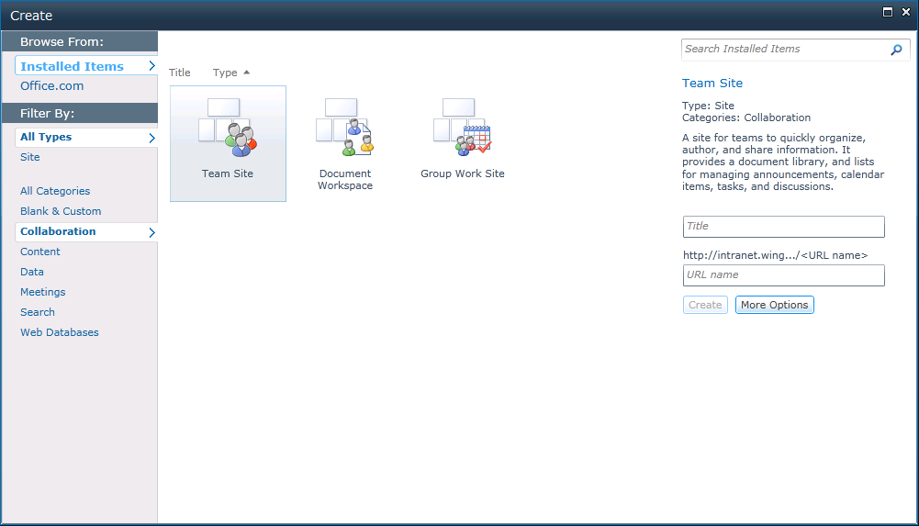

On the new marketing site that's created, notice the **Get Started** section at the bottom right of the page. The links in this session can be used to set security for the site, change its theme, set a site's icon or logo and customize the Quick Launch bar that appears at the left of the page.

1. Select the **Change site theme** link. The Site Theme page presents you with the built in themes you can choose to apply to your site. In addition to applying these themes as-is, you could also modify certain styles and then apply your modified theme.

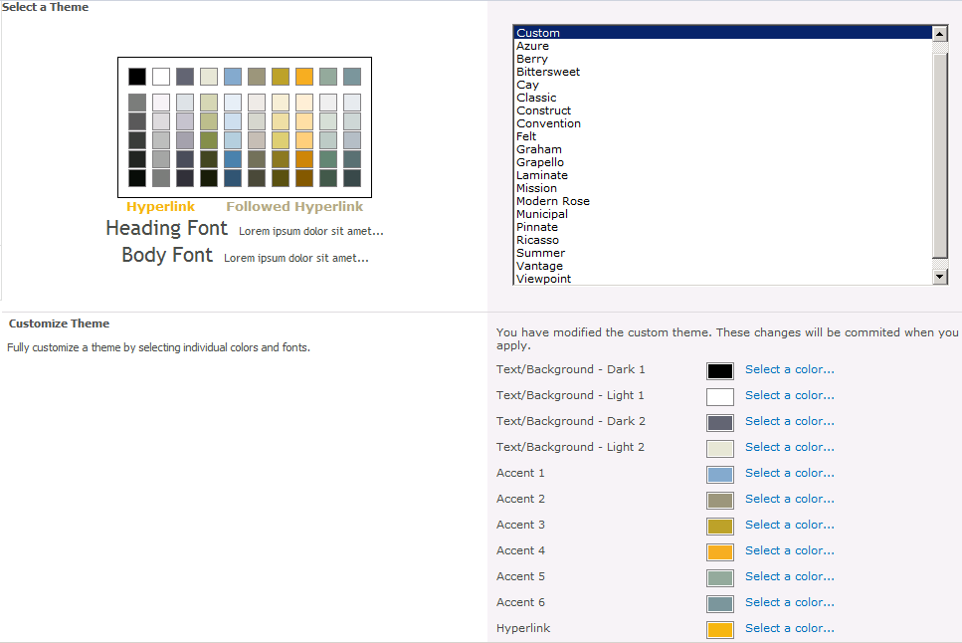

1. Choose the **Convention** theme and Select the **Apply** button at the bottom of the page to apply it to the site. You will be taken to the **Site Settings** page of the site. Observe the change in the font and colors of the site.

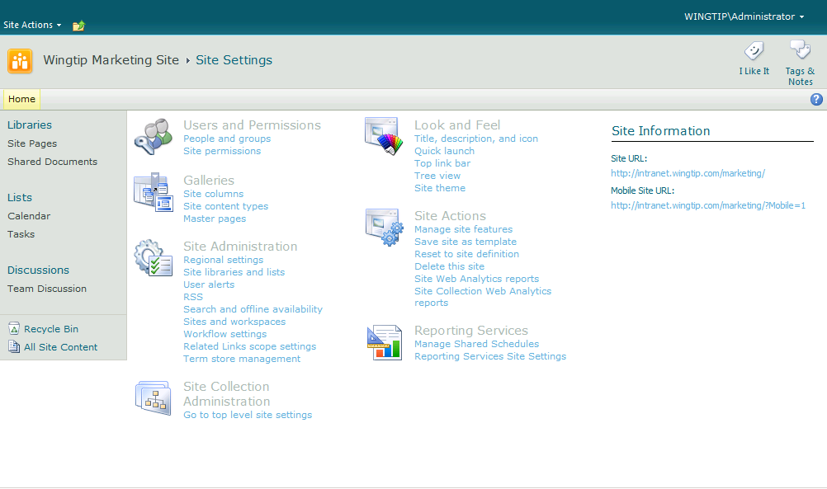

In this exercise, you learned how to create a SharePoint site and apply a theme to it.

### Exercise 2: Working with the SharePoint 2010 Ribbon and In-place Editing

In this exercise, you will complete work inside the top-level site of the site collection. You will begin by adding and viewing items inside of some of the lists that are automatically created as part of a new Team site so you can experience the new paradigm for in-place editing. After that, you will work with a Web Part Page so you can experience how the SharePoint 2010 user interface lets users manage Web Parts.

1. In a browser, navigate to **http://intranet.wingtip.com/marketing/SitePages/Home.aspx**.

**Note:** The home page is not default.aspx but rather a wiki page named Home.aspx located inside a wiki page library named Site Pages.

1. Observe that the page Home.aspx already contains some generic content including large text block at the top of the page which reads "Welcome to your site!". Go into edit mode for the wiki page by clicking **Site Actions » Edit Page**. Once in edit mode, change the entire section of text that begins with **"Welcome…"** to **"Wingtip Marketing Site"**. Use the font toolbar buttons in the ribbon to give your new text a font with a size and a color to your liking.
2. While still in edit mode, delete the graphic of the generic stock photo that has been placed on the right-hand side of the page. Now it’s time to add a different photo. Place you cursor on the page at the position where the old photo used to be. Inside the ribbon, select **Edit Tools** (contextual tab group) **» Insert** (tab) **» Picture** (button) to add a new picture to the page which should bring up the **Add Picture** dialog shown:

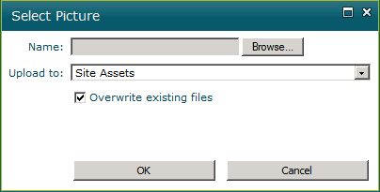

Note that the **Add Picture** dialog will allow to select a graphic image which will be automatically uploaded and stored in a special document library named **Site Assets** Library. Click the **Browse** button of the **Add Picture** dialog and navigate to and select the image at the following image: [[LAB FILES]]\StarterFiles\Rob.jpg. When prompted after uploading, **Save** the file.

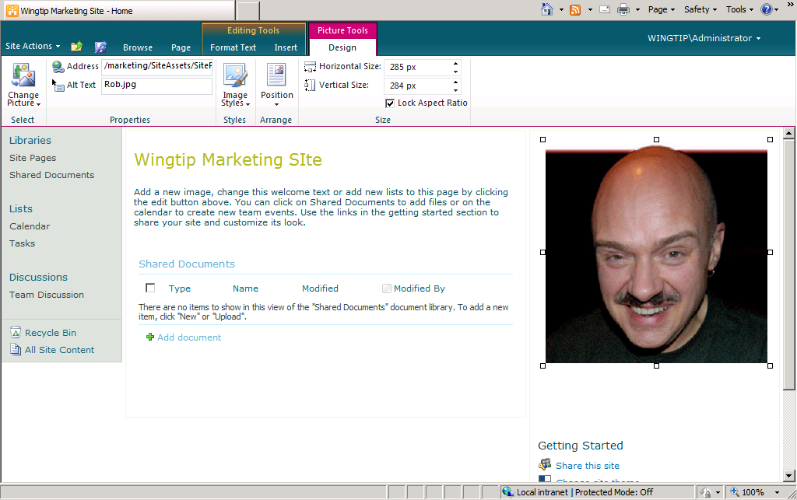

1. Now that you have made some cosmetic changes to the home page, save your changes using the ribbon by selecting **Editing Tools »** **Format Text**, select the drop-down on **Save & Close** and select **Stop Editing**. When prompted, pick the option to save your changes.

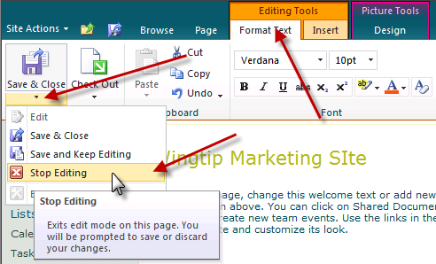

1. Now it's time to explore some other parts of the new site. Drop down the **Site Actions** menu and see what menu items are available. Select the **Site Actions » Site Settings** to navigate to **Site Settings** page. Inspect all the various links to the various administration pages that have been designed for site collections owners and site administrators.
2. Select **Look and Feel** » **Title, description and icon** which takes you to a page where you can see the title and description you entered for the site in the previous exercise. Enter a new value for the **Logo Url** to assign the site a different site icon. You can use one of the following URLs which point to images that are part of the standard installation for SharePoint 2010.

/_layouts/images/search.png

/_layouts/images/unknownperson.png

/_layouts/images/gears_an.gif

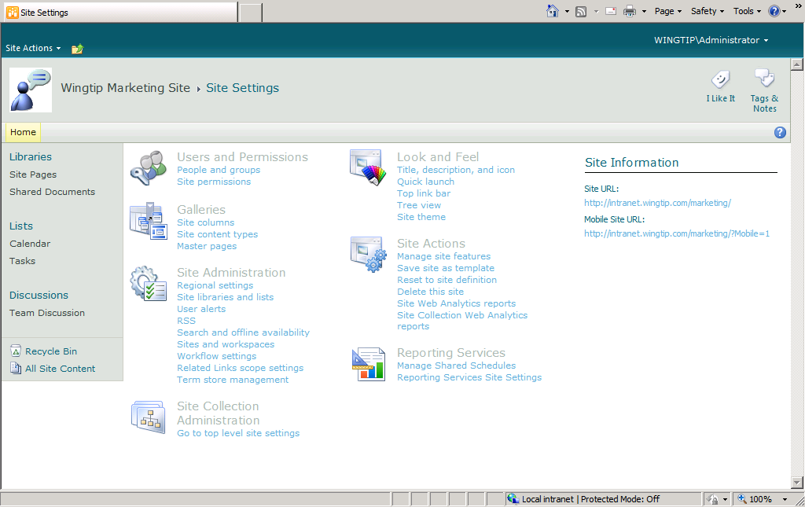

1. Now it is time to add a new item to a list so you can experience working with the new server-side ribbon and in-place editing. Select the **Tasks** link in the **Lists** section of the Quick Launch bar to navigate to the **Tasks** list which was created as part of every new Team site. You should observe that there are no existing task items in this list. You should also observe the **Task** list has an associated server-side ribbon with a set of tabs including **Browse**, **Items** and **List**. Select each of these tabs to see how the ribbon changes to display a contextual set of controls for a given set of tasks.
2. Select **Items » New Item » Task**. This action will display an input form for you to enter the data for a new task item and to click **OK** to save the new task item back to the content database. The next step will provide you with the data for the new task.

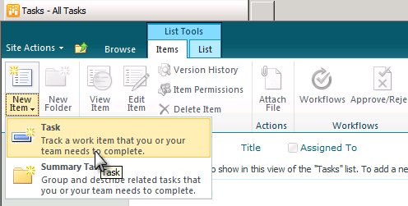

1. Create a new task using the following information:

**Title**: Learn how to develop on SharePoint 2010

**Predecessors**: none

**Priority**: (1) High

**Status:** In Progress

**Complete**: 2%

**Assigned To**: Wingtip\Administrator

**Description**: Find out how to develop useful solutions

**Start Date**: 8/1/2009

**Due Date**: 8/4/2009

1. Create a second new task using the following information:

**Title**: Develop Solutions on SharePoint 2010

**Predecessors**: Learn how to develop on SharePoint 2010

**Priority**: (1) High

**Status**: Not Started

**Complete**: 0%

**Assigned To**: Wingtip\Administrator

**Description**: Begin developing solutions on SharePoint 2010

**Start Date**: 8/5/2009

**Due Date**: leave blank

1. Once you have created the two tasks from the previous steps, experiment with the list view if items in the task list by hovering over individual items. Note that each item highlights as you hover over it and the UI gives you the ability to select it. Use the ECB menu (the standard SharePoint item-hover menu) to go into edit mode for one of the tasks you have created as shown below. Make a simple edit to the task and save it to observe the in-place editing behavior.

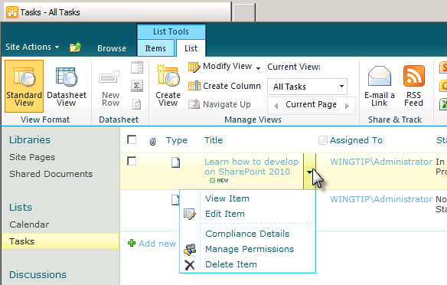

1. Now it is time to add a Web Part to a Web Part Page using the new UI experience for managing Web Parts. Navigate to the page default.aspx which is located at the root of the site. Note the built-in navigation scheme does not have a link to this page in a new team site so you should type the following URL into the browser's address bar: [**http://intranet.wingtip.com/marketing/default.aspx**](http://wingtipserver/sites/Lab01A/default.aspx).
2. Note that the ribbon on this page like any other Web Part page has two tabs titled **Browse** and **Page**. Select each of these tabs and see how the contextual controls on the ribbon change for each of these tabs. Select **Page** » **Edit Page** button that takes you into the mode for adding, modifying and deleting Web Parts from the page.
3. Delete the two existing Web Parts (**Announcements** and **Calendar**) in the **Left** Web Part Zone by clicking on the **Delete** command inside their Web Part menu.

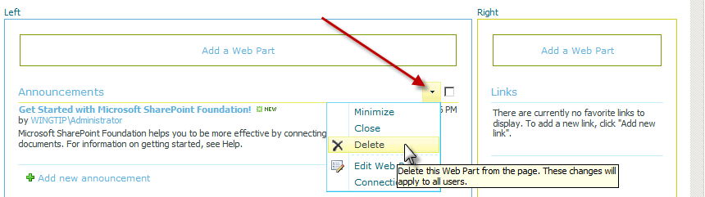

1. Now that you have deleted those two Web Parts from the **Left** Web Part Zone, it is time to add a new Web Part to display the tasks inside the Tasks list.
   1. First, make sure the **Left** Web Part zone is selected (selected Web Part zones are indicated with a dotted border) so that contextual **Page Tools** ribbon tab is displayed. Select the **Insert** tab on the ribbon and Select the **Web Part** button which is shown below.

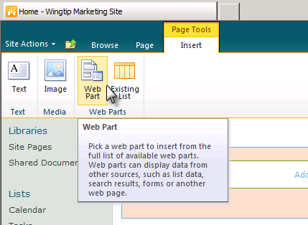

1. You will see the UI for adding new Web Parts to a page. Select **Lists and Libraries** in the left-hand section and then select **Tasks** in the right-hand section. Once you have select the Tasks list, make sure the drop-down box on the far right bottom (shown below) has the Left Web Part zone selected, then click the **Add** button to add the Web Part instance to the page.

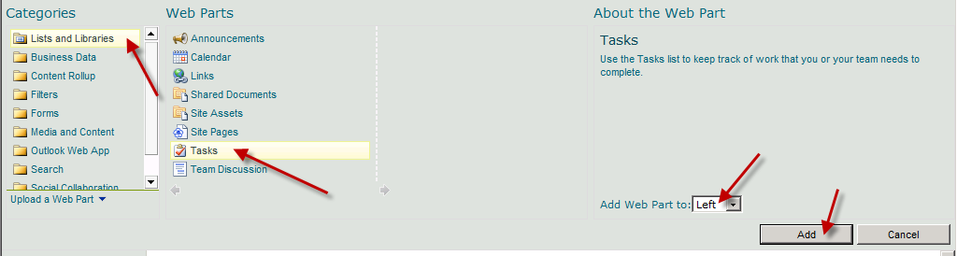

1. Save your changes using the ribbon by selecting **Page » Stop Editing**. Now that you have completed this exercise, you should have a page that looks like the one shown below.

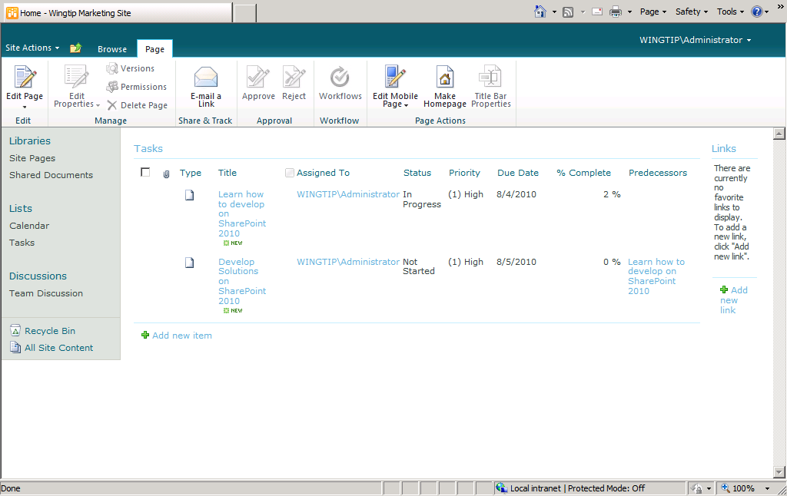

In this exercise, you got hands-on experience in working with the components of SharePoint user interface such as the ribbon and adding Web Parts to a page.

### Exercise 3: Exploring the Central Administration Site

This exercise will guide you through the Central Administration of SharePoint. You will observe the options available to manage a SharePoint deployment at the Farm and Web Application level, but will not be making any changes here. Keep in mind that in a production environment, very few people should have access to manage the options in the Central Administration site.

1. Navigate to the **SharePoint 2010 Central Administration** site.
2. Explore the various pages of the Central Administration site by clicking the links in the Quick Launch bar such as **Application Management**, **System Settings** and **Monitoring**. This should give you an idea of how the Central Administration site breaks up management tasks into different functional areas.

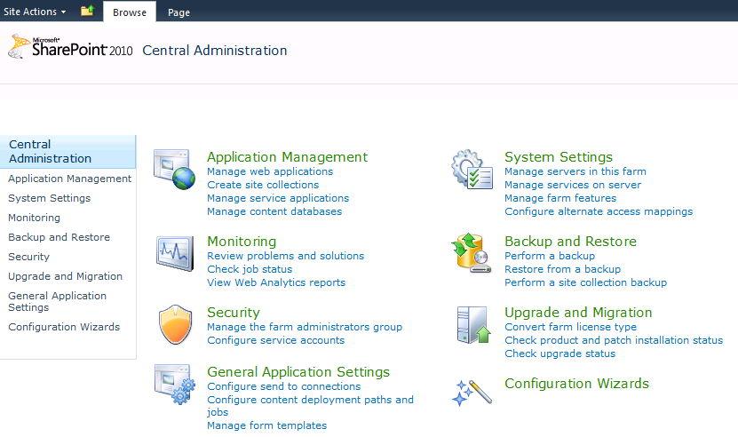

1. Select the **Application Management** link in the Quick Launch bar to navigate to the **Application Management** page. Inside the **Site Collections** section of this page, you should see several links for creating and managing site collections. Click in the link titled **View all Site Collections** which takes you a page which shows you the site collections currently existing in a Web Application.

By clicking on the individual site collections on the left, you should be able to view information about each site collection on the right of the page.

The next thing you will observe is the range of options you have available to you for backing up and restoring components of SharePoint.

1. Select **Backup and Restore** link in the **Quick Launch** bar. Note that the two main groups of options here show that you can do a backup at the farm level or a granular backup at the site or list level. Select **Export a site or list** under **Granular Backup** heading. You should now see the Site or List Export page where you can select a specific site or list/library to export.

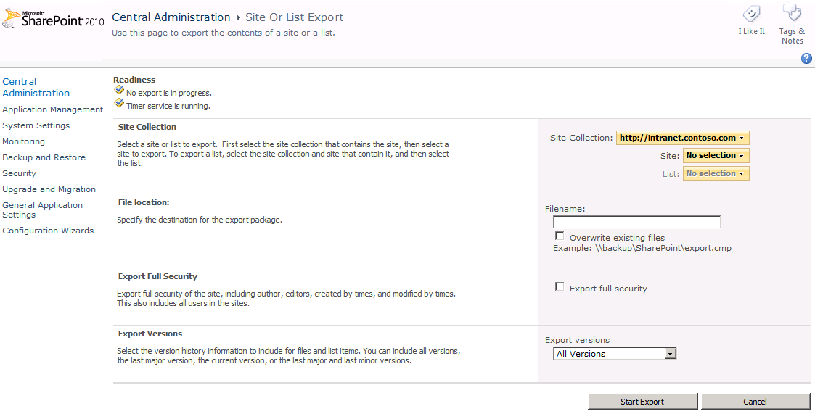

In this exercise, you explored some of the options available in the Central Administration site. Once again, keep in mind that in a production environment, only server administrators should manage the settings on these pages.